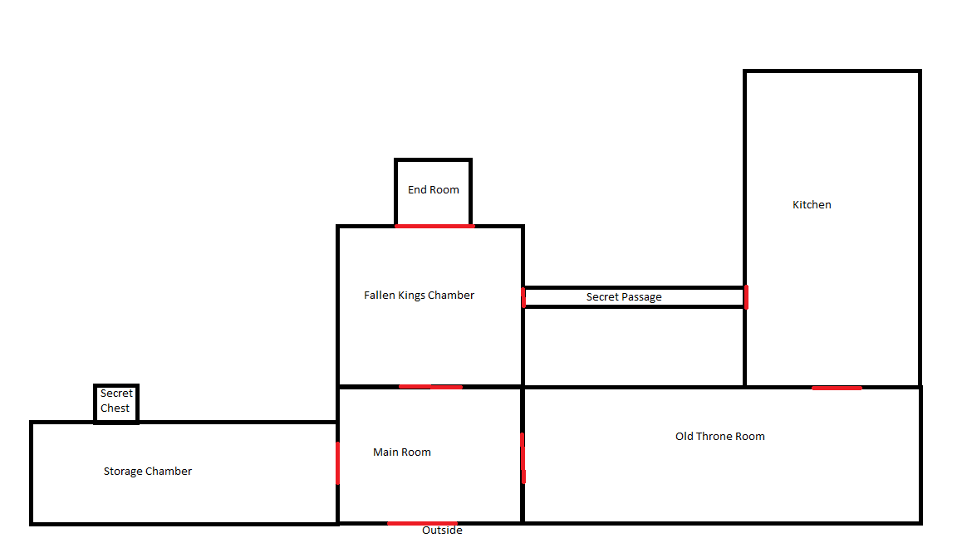***Walkthrough***

* You begin the game in the main room of the palace.
* Head west using “go west” to head into the storage chamber.
* Use the “look carpet” command to uncover a key hidden underneath.
* Use “take key” to add the key to your inventory.
* Head east back into the main room with “go east” and then east again into the throne room.
* Look at and take the lamp on the wall using “look lamp”
* Next use the key with “use key” to unlock the door into the kitchen
* Move north to enter with “go north”
* Look at and take the box of matches mentioned in the room’s description (if the look command is used).
* Now look at the crate also mentioned in the description. Doing so will reveal the secret passage.
* With the “use” command use either the lamp or the match to light the lamp and unlock the passage.
* “go west” into the secret passage and west again to move into the king’s chamber.
* On the ground in the room are 3 tiles, each matching a damaged area of wall above the king’s bed but with different designs. “take tile2” (This design matches the family crest seen in the main room) and “use” it.
* Doing this will open the door to the end room.
* “go north” into the end room to trigger the games ending.

Mini ending

* To trigger the second secret ending, at any point during the game go back to the main room and head south to the outside. Doing so will trigger the ending where the player gives up on finding the treasure.